Setting up a Sharded Cluster

1. Log into mongos Console

[root@localhost tom]# mongo

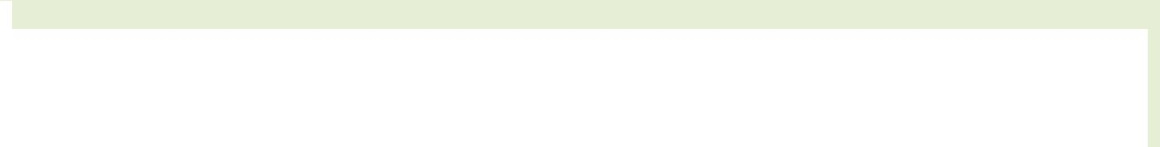

MongoDB shell version: 2.6.3

connecting to: test

mongos>

2. List all Databases

mongos> show dbs

admin (empty)

config 0.016GB

3. Switch to config database

mongos> use config

switched to db config

4. List all Collections

mongos> show collections



changelog

chunks

databases

lockpings

locks

mongos

settings

shards

system.indexes

version

MongoDB Hands-on Page 1

Setting up a Sharded Cluster

5. Add the Three Shards on Mongos

mongos> sh.addShard("ReplicaSetNew1/localhost.localdomain:27011")

{ "shardAdded" : "ReplicaSetNew1", "ok" : 1 }

mongos> sh.addShard("ReplicaSetNew2/localhost.localdomain:27021")

{ "shardAdded" : "ReplicaSetNew2", "ok" : 1 }

mongos> sh.addShard("ReplicaSetNew3/localhost.localdomain:27031")

{ "shardAdded" : "ReplicaSetNew3", "ok" : 1 }

6. Check Status of the sharded cluster

mongos> sh.status()

--- Sharding Status ---

sharding version: {

"_id" : 1,

"version" : 4,

"minCompatibleVersion" : 4,

"currentVersion" : 5,

"clusterId" : ObjectId("53bdcc24ecb20b84c96f5914")

}

shards:

{ "_id" : "ReplicaSetNew1", "host" : "ReplicaSetNew1/localhost.localdomain:27011,localhost.localdomain:27012,lo calhost.localdomain:27013" }

{ "_id" : "ReplicaSetNew2", "host" : "ReplicaSetNew2/localhost.localdomain:27021,localhost.localdomain:27022,lo calhost.localdomain:27023" }

{ "_id" : "ReplicaSetNew3", "host" : "ReplicaSetNew3/localhost.localdomain:27031,localhost.localdomain:27032,lo calhost.localdomain:27033" }
databases:

{ "_id" : "admin", "partitioned" : false, "primary" : "config" } mongos>

MongoDB Hands-on Page 2

